 MIT5: creativity, ownership and collaboration in the digital age
The Knowledge Gates to SecondLife Friday, April. 27, 2007, 2:15-3:45 p.m.

Mary E. Hopper, Ph.D., K-Foundry.com & Northeastern University Digital Media Program

There are many sites in SecondLife that contain interesting and valuable content,
but most of them receive little traffic and never appear in the popular places list.

One goal of this project is to increase the traffic of those places enough to impact
the makeup of the popular places list and thus the perceived make-up and purpose
of SecondLife itself to a land of knowledge representation, access and exploration.

This project includes a series of virtual places that employ a variety of metaphors
and contain carefully conceived objects framed within thematically organized spaces
that integrate and expedite access to sources of content in SecondLife and the WWW.

The project then goes further by also creating and promoting participation structures,
resources, and standards to motivate and support others in constructing their own
virtual knowledge objects, spaces, places, regions and even kingdoms in SecondLife.

You can easily find the K-Gates to SL once you are in the virtual world.
Just search "Places" for "K-Gates", select a location and click teleport.

Opening Comments

1. No longer about pornography. Linden Lab policy changes are starting to clean that up already.

2. No longer about number of users. That argument is becoming equal to the importance about the size of cities vs. importance.
After a certain point, does it matter? (Cambridge, MA = 100,135 | Washington, D.C. = 550,521 | Boston, MA = 559,034)

SecondLife is clearly a large international community space that is always populated both day and night. It truly never sleeps!

3. Clearly a next level of user interface paradigm. It is no more Web 2.0 than WWW was Windows 2.0 or Windows was DOS 2.0.

4. The issue is becoming more about the POWER of the system, and it definitely meets my favorite litmus test.

How do you build a world?
How do you build tools for that world?
How do you get your friends into that world to create knowledge together? --Matt Hodges, 1991

In other words, can you build a world with the system, are there tools to build the world built into it,
can you get your friends, students or clients into the world and can they help to build the world too?

5. My own test has been whether or not it could support my own personal pet project. Can it support a “Knowledge Palace”? YES!

Introducing K-Gates, a general knowledge system that is free, open to the public and constructivist!

• Five layers of increasing access, involvement and interpretation.

• Multiple sites that each support various aspects of the five layers of access and involvement.

Note that this site is not funded by an advertising model. The sites/gates are chosen based upon quality of content.
There is no fee paid by destination site owners or the vendors represented within the K-Gates sites themselves.

The K-Gates project is entirely supported through donations, and they are always accepted and greatly appreciated.
The long term goal is to establish a non-profit organization and find funding to establish a trust to support the project.

Biographical Statement

Mary Hopper is president of Knowledge Foundry, a firm that specializes in the construction of virtual knowledge spaces.
She also is serving as an instructor in Northeastern University’s new Digital Media Program. Prior to joining Northeastern,
she served as Assistant Professor in Lesley University’s Technology in Education Program and Postdoctoral Associate in
MIT’s Comparative Media Studies Program. Hopper has a Ph.D. in Educational Computing, M.S. in Educational Psychology,
and B.A.in English Education (1985) from Purdue University.

Five Layers of Increasing Involvement and Interpretation

The K-Gates system is deliberately designed to help users evolve from explorers to participants and, ultimately, builders of knowledge.

1. Extended Welcome Area  Extended welcome areas with “Magic Gates” that give landmarks to over 200 of the best sites in SecondLife.  Thematic approach for exploring the wonders of SL.  The parks also include freebies and talented objects.  Something for everybody, newbies and experienced.  Magic Gate Manufacturing Facility →  Goal: Adding 1000 Magic Gates (SL Sites) /Year | 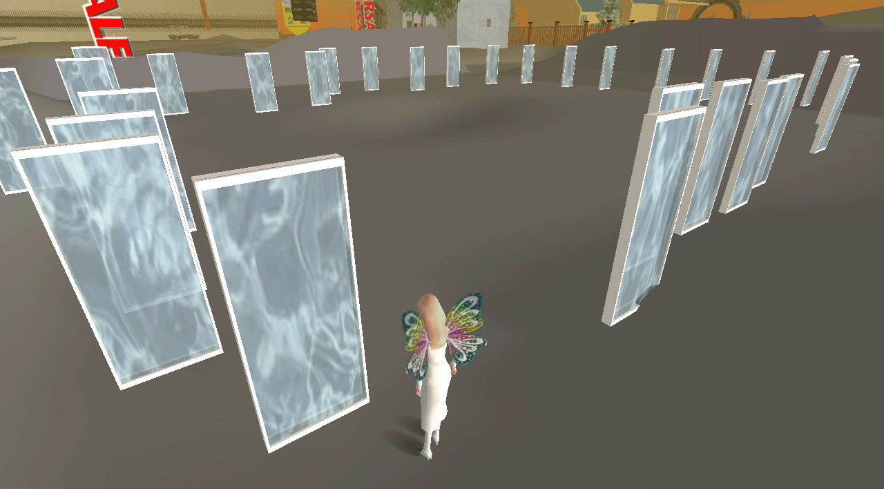
2. Knowledge Interface  There are about 100 Web Windows that link to pages with links to top entries from these key resources on the web.  • Wikipedia (Primarily the top level academic disciplines.)  • Internet Public Library Pathfinders and Subjects (1000s)  • WWW Virtual Library Pages (Most of the existing sites.)  • Kathy Schrock’s Guide to Educational Resources  • MIT’s Open Courseware (Almost every course.)  Goal: Total Access to 10 More New Sources / Year | 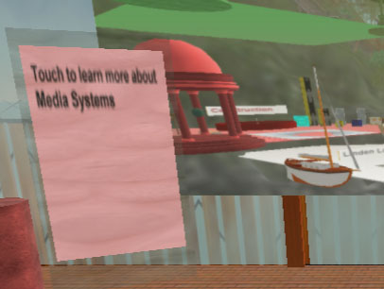
3. Community Membership  Introduction, Participation, Personalized User Support,  Common Facilities & Pre-Release Preview & Parties!  This provides scaffolding for users that can transition from non-participants to considering more extensive investment.  Buying property for own build can cost thousands of US$!!  Goal: Introduce & Include 100 Users / Year | 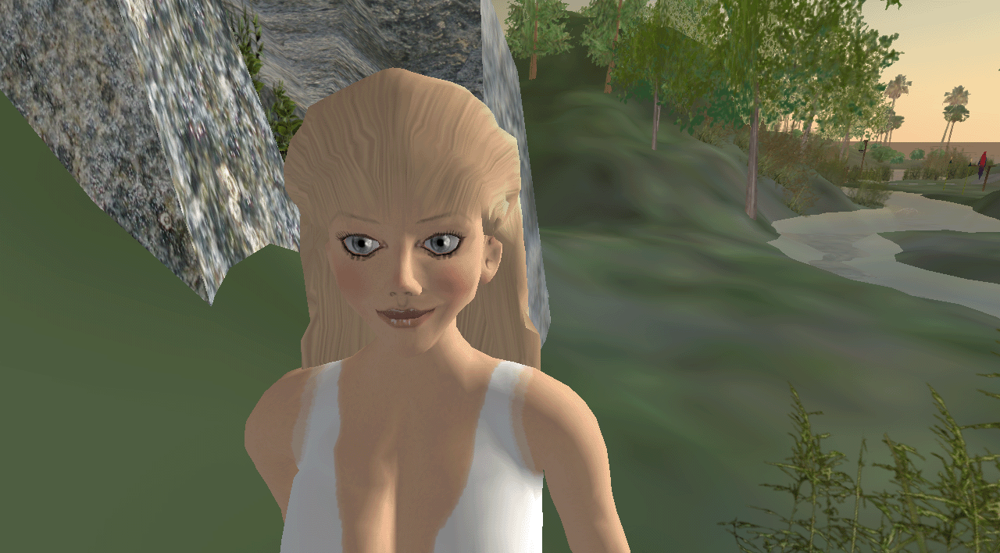
4. Construction Resource  Building Resources, Free Templates & Case Studies  The degree to which this project itself functions in this  way is not immediately obvious, but the explanation  is part of the tour offered to members. | 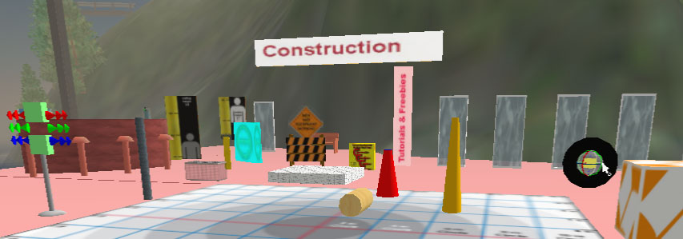
5. Communication Systems Theory Framework  There are hidden levels of K-Gates that provide a context  for presentation of a theory used to construct the system, and the project itself is an embodiment of that theory.  The theory is presented within the system to provide guidance for others seeking to build knowledge systems. | 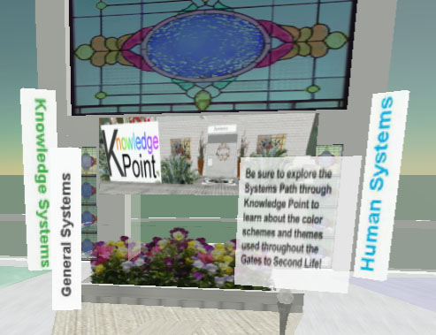
Two Sites that Support Aspects of Five Layers of Access  Two key virtual places that employ a park metaphor  and contain carefully conceived objects framed within thematically organized spaces that integrate and expedite access to sources of content in SecondLife.  The sites are roughly organized by categories of the  Propædia, the volume of Encyclopædia Britannica  containing an outline of knowledge.  These two locations are strategically located very near the public versions of Help Island, Orientation Island and in the  heart of Linden Village. |  |  | 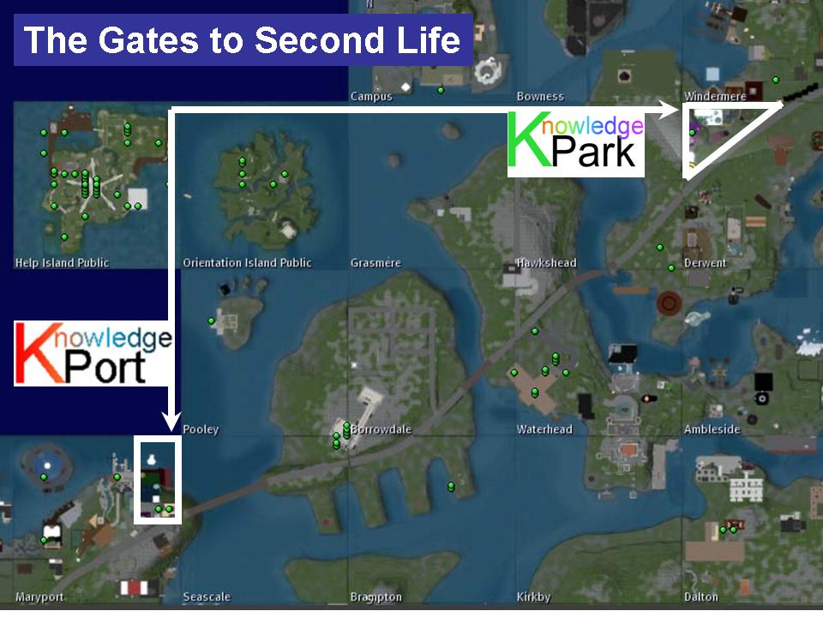
K-Port, K-Gates, Construction Resources!  Lots of freebie building tools & Magic Gates to great tutorials and sources for construction!  SLURL: MaryPort/214/228/21  Size: 5,120 sq. m.  High Traffic: 546 (Apr 20, 2007) |  | 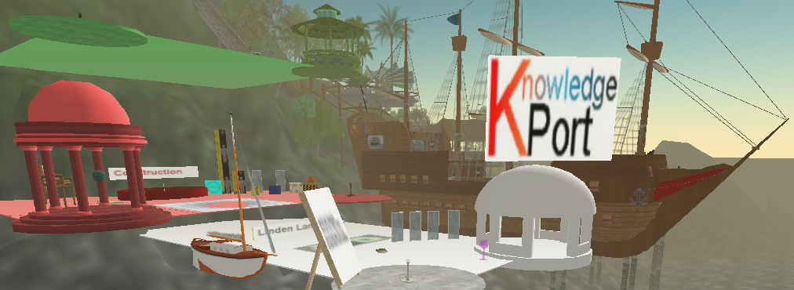
K-Park, K-Gates, Exploration Nexus!  Peaceful park with many Magic Gates that give landmarks to the most interesting wonders & adventures in SL!  SLURL: Derwent/9/152/34  Size: 9,072 sq. m.  High Traffic: 1067 (Apr 2, 2007) |  |  | 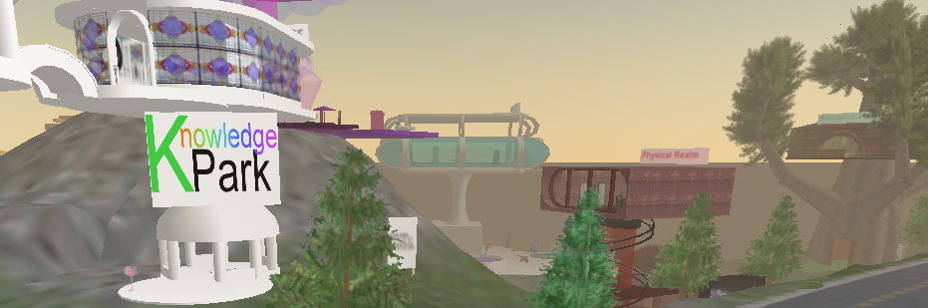

Two sites with introduction to Communications Systems Theoretical Framework

K-Point-East, K-Gates, Communication Systems Center!  Knowledge Point, K-Foundry Conference Center  The main attraction is the Communication Systems Center.  It provides master info. and access point to other sites.  SLURL: Alston/18/173/66  Size: 2,512 sq. m.  High Traffic: 161 (Apr 13, 2007) | 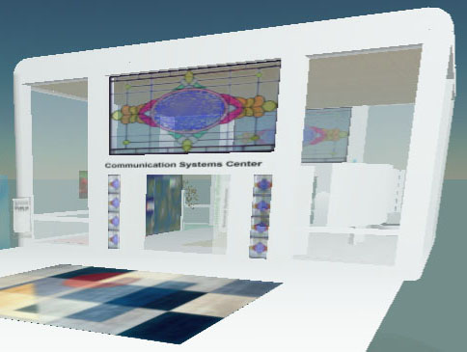
K-Point-East, General Systems Garden Path  Learn about color schemes and themes used in K-Gates!  SLURL: Alston (Co-Located with Welcome Area)  Size: 5,624 sq. m.  High Traffic: 207 (Apr 12, 2007) | 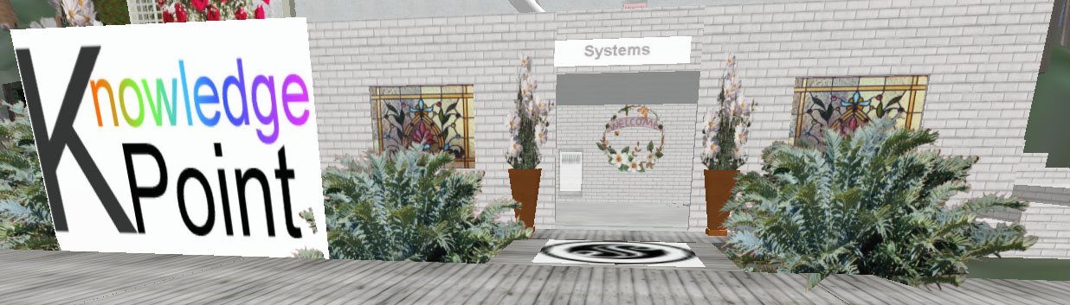

NOTE: K-Gates sites do not take advantage of well-known methods such as camp chairs used to inflate traffic figures in Second Life.
Traffic is a limited measure of success for this project because the primary function of K-Gates is to direct users to other valuable sites.
We are working on a Magic Gate and Web Window use statistic to provide a more accurate metric for reflecting use of the project.

The area of the project is almost the size of a full region, but the sites are distributed across five regions. This is a strategic decision.
A region only supports between 30-50 avatars at a time. K-Gates deliberately uses a distributed land strategy to increase capacity of
the system to 150-250 avatars (5 times a single region). Therefore, the traffic is best interpreted as cumulative over the various sites.

