Dear family and friends, November 29, 2021

Despite arthritis manifesting this year, I photographed 195 avian species in MA,
topping my previous high of 186. Two mammals I saw, and regretted failing to
photograph, were mink and woodchuck.

I got 5 jabs this year, for COVID, flu, and shingles. To the vaccine hesitant: Watch
this space. Not that it will prove anything either way. Correlation is not causation.

In June MaryDan and Bob came here for my 75th birthday and their 52nd anniversary. I had a dinner party, we dined out à trois, and we visited Helen Gillcrist. We collaborated on a 500-piece custom jigsaw puzzle while listening to records. MaryDan and I got lost in the Middlesex Fells.

In July Phil Tracy, my Go friend from Syracuse, was a house guest. Even though he
used to live in Boston, I introduced him to Walden Pond. Later in July I attended my
sister-in-law Irene’s 90th birthday party.

In August Sue Baker Olson, a friend from the U of I, visited me. We did the MFA
and gabbed. Also that month I enjoyed a couple of nice luncheons with Irene.

In October the 3 Coopers and I visited Ed Luedke at his home in Lake Forest, California. We loved meeting Ed’s daughter Karen and her family. We walked Laguna Beach, and attended the Pacific Symphony. Ezra, who had not met this uncle before, said he was so glad he came, adding “I had no expectations.” Ed quipped, “You had low expectations?” From there we flew up to Seattle for an early Thanksgiving with Ezra and Michal. I checked out the wonderful Seattle Go Center. On a hike in Seward Park I photographed pied-billed grebes and Anna’s hummingbird. We did a couple of crossword puzzles as a group.

While I was away in October Irene had a car accident! I only had a chance to visit
her twice before she died Nov. 1. RIP Irene Bettencourt D’Entremont.

Home improvements: Aileen and Eamon landscaped my yard! I automated my garage door. One column of my balloon insulation that was missed out in 2018 is now filled.

In the Spring I played in an online Go Tournament. In the Fall I participated in the MGA league.
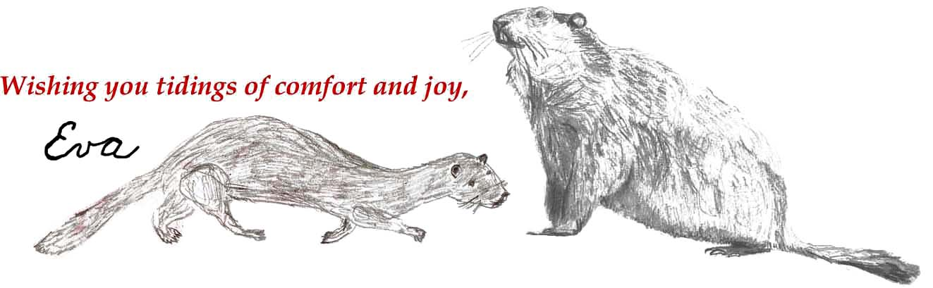
evacasey@rcn.com http://theworld.com/~eva

