Dear family and friends, December 10, 2022

I spent last Christmas in good company at the home of Gail (Irene’s niece) and Mark.

MaryDan, Bob, and I canceled our plans to celebrate Bob’s 75th birthday in January together due to weather. Instead we celebrated belatedly, in June, at the New Skete Eastern Orthodox Monastery guest house in upstate New York. Great place!

February 21-24 MaryDan and our cousins Marie Drumm and Kathy McCann, gathered
at my house for visiting, meals, and walking. Kathy introduced us to Wordle.

I uploaded photos to ebird for the first time. I racked up steps birding with my rollator,
often with Genie Johnston. In Wompatuck we both got a good look at a mink which
only Genie managed to photograph.

I swam at Walden Pond 25x last summer, and at the Y near my house other seasons.

I played in Trevor Morris’s local two-day Go Tournament Labor Day weekend, and in
one of Milan Mladenovic’s well-run enjoyable online MGA League tournaments.

September 24-October 9 Kathy McCann and I toured Japan with O.A.T., a trip postponed since 2020. On one of our free afternoons in Tokyo I played Go at the Nihon Ki-in! One of my favorite things in Japan was the hot springs, and they were not just in Hakone, a resort famous for hot springs in sight of Mt. Fuji. We ate box lunches on the bullet train. We also rode busses, subways, cabs, and boats. We took a day trip from Kanazawa to Gokayama, a mountain village with thatched houses now a UNESCO World Heritage Site. I came to appreciate Sushi, and Kathy, Saki. We broke into small groups to enjoy hospitality in private homes. We had a good group and Takashi was a fabulous leader.

Bill and Linda Holden visited me, and so did Marina Wong, in town from Texas and
Florida respectively, to visit family. Eileen Doherty (St. Bride’s ’60, Aquinas ’64) was
in town a couple of times. Her good friends in JP included me in their Thanksgiving.

Home improvements: Aileen and Eamon, who also do carpentry, repaired my garage. I added a bird bath to my backyard, and my hot water heater was replaced within a day of failing. I continue to chip away at emptying my attic. I hired a cleaning service.

I am a news junkie. The one news item on my card stands in for the whole.

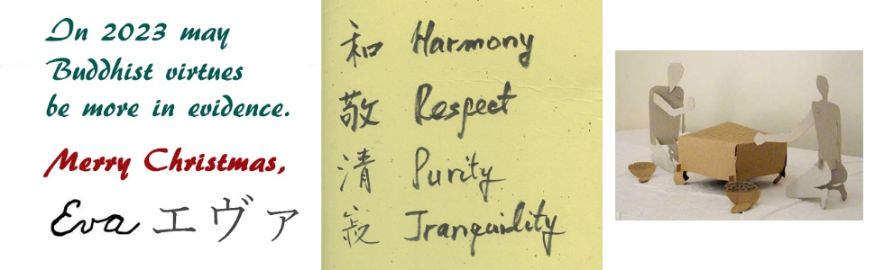
evacasey@rcn.com http://theworld.com/~eva

